NAME : PAREENITA ATUL SHIRSATH PRN : 221101062 ROLL.NO : 57 T.E.A.I.&.D.S.

**SEPM EXPERIMENT : 3**

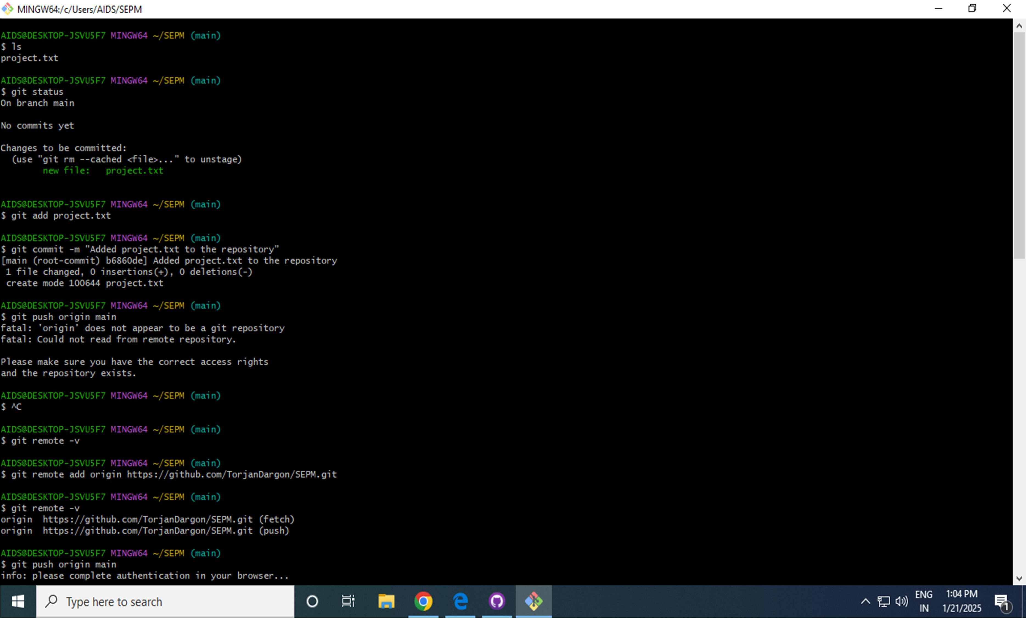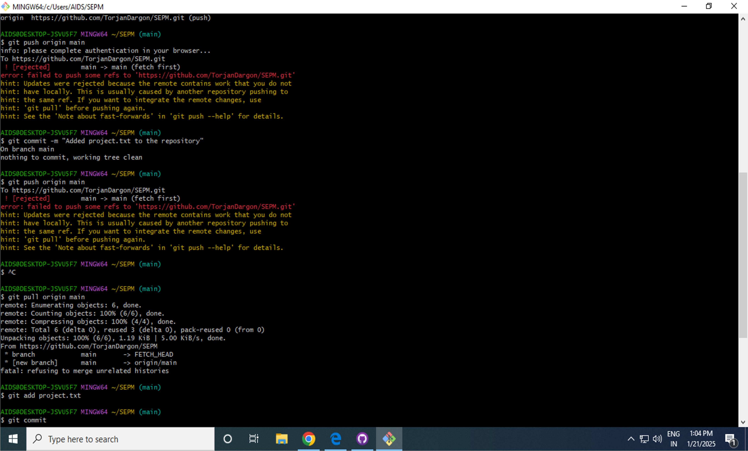

**GIT COMMANDS: -**

• Git Status - The git status command displays the state of the working directory and the staging area. It lets you see which changes have been staged, which haven't, and which files aren't being tracked by Git.

• Git add [file] - The git add command adds a change in the working directory to the staging area. It tells Git that you want to include updates to a particular file in the next commit.

• Git reset [file] - This is the default argument for git reset. Running this command has two impacts: (1) uncommit all the changes(2) Unstage them.

• Git commit –m - To add a Git commit message to your commit, you will use the git commit command followed by the -m flag and then your message in quotes.

• Git push - The Git push command is .used to push the local repository content to a remote repository. After a local repository has been modified, a push is executed to share the modifications with remote team members.

